The Depth of Traversal
  - Why a Closed Timelike Curve Does Not Reverse the Order of Experience
Joseph Shields
Working paper · 2026

A closed path is not automatically a reversed journey. A system may return to a labelled point while still carrying the completed traversal that brought it there. This paper develops that distinction from the observer outward: age, memory, entropy, physical state, and finally the geometry of the loop itself.

Abstract
Gödel-type spacetimes permit closed timelike curves: future-directed timelike paths that return to their starting spacetime event. The usual picture is a circle. This paper argues that the circle suppresses a physically decisive dimension—the depth created by traversal. An observer moving through A → B → C does not encounter the original A again as an unexperienced occurrence. The return is A after B and C, and therefore belongs to a new traversal index. When that index is retained, the circle unfolds into a helix: the relational pattern repeats, but the occurrence does not. Recent quantum treatments make the same pressure visible by requiring the traveller’s state, memory and entropy to return to their initial values. Such recurrence may secure mathematical consistency, but it does so by imposing a reset or reversal on the very history that would make the trip a meaningful return to one’s own past. The central claim is therefore interpretive and physical rather than algebraic: geometric closure does not by itself establish reversal of elapsed evolution.

1. The Problem Begins with the Observer
Gödel supposed a universe in which the global structure of spacetime permits closed timelike curves. This is usually described as a route through spacetime that eventually returns an observer to the same event. But the observer is not merely a location on the route. The observer is a physical system undergoing the route.
The first question is deliberately ordinary: what happens to the observer’s age? “Age” here means exactly what it normally means—the time the observer has actually lived through. The observer’s body changes, their clocks advance, their memory changes, and their physical state accumulates the journey. These changes are not external annotations placed on the curve. They are part of what it means for an observer to traverse it.
This creates the basic tension. The geometry says that the route closes. The observer says that the route happened. If the traveller reaches the labelled starting point only after completing the journey, then the returned occurrence already contains a history that the original occurrence did not.

2. Geometry and Physics Must Make Sense Together
The argument is not that Gödel’s metric fails as a solution of Einstein’s field equations. The argument is that a geometrically closed path and a physically identical recurrence are not the same claim. Geometry may identify endpoints. Physics must still explain the state of the system that arrives there.
Let an observer follow a timelike worldline
γ : [0,T] → M, with γ(T) = γ(0).
The equality states geometric closure: the endpoint and starting point are the same event in the spacetime manifold. Yet the observer’s proper time along the path is
Δτ = ∫₀ᵀ √(−gᵤᵥ γ̇ᵘ γ̇ᵛ) dλ > 0.
The observer therefore undergoes a nonzero duration while travelling from the start back to the start. The two statements can coexist mathematically, but they do not mean the same thing:
γ(T) = γ(0) does not mean Δτ = 0.
The route can close while the traversal remains completed. The physical question is what becomes of that completed traversal when the endpoint is identified with the beginning.

3. Existing Quantum Models Reveal the Same Pressure
David Deutsch modelled a quantum system interacting with a closed timelike curve by requiring the state on the curve to be a fixed point of the total interaction. In a standard notation,
ρ_CTC = Tr_ext[ U(ρ_in ⊗ ρ_CTC)U† ].
This condition does not describe an unrestricted observer simply moving backward through their own history. It requires the loop state to be self-consistent after the full interaction. The state is permitted only if the end of the loop reproduces the state required at its beginning.
A more recent analysis by Lorenzo Gavassino places an isolated spaceship and observer on a closed timelike curve in an axially symmetric setting. The internal quantum system is constrained so that it returns to its initial state after the round trip. Memory must be erased by the end of the journey, and any entropy increase must eventually be reversed so that the loop closes consistently.
This is a brilliant result because it exposes the issue rather than removing it. The model can close only by making the traveller’s accumulated physical history unwind. That immediately raises the human question: if the observer’s memory, ageing and internal change are all reversed before closure, in what meaningful sense did that same observer return carrying a journey into their past?
The mathematics describes a self-consistent recurrence. It does not automatically establish the ordinary idea of a traveller who remembers leaving, travels around the loop, and then arrives in their own earlier world as the same continuously accumulated person.

4. The Circle Hides the Order
The usual representation of a closed timelike curve is a circle:
A → B → C → A.
But an observer cannot experience this sequence as a simultaneous circle. The observer experiences it in order: A, then B, then C, then the return toward A. Once C has occurred, the next A cannot be the unexperienced original A from the observer’s point of view. It is A after C.
The moment C recognises A as the start of a new loop, a boundary has already recorded the previous set. The completed traversal distinguishes the returned A from the first A. The labels may repeat, but the occurrences do not.
A₀ → B₀ → C₀ → A₁ → B₁ → C₁ → A₂ → ⋯
This indexed sequence is not an extra story imposed on the traveller. It is the minimal record of the order the traveller must actually undergo. If the indices are erased, the geometry appears circular. If they are retained, the route has depth.

5. Giving B Depth
In the flat circle, B is treated only as a midpoint or relation between A and C. But once traversal is preserved, B does more. B is the passage by which one occurrence of the pattern becomes the next occurrence. It is therefore the depth-bearing relation.
The first traversal is
A₀ → B₀ → C₀.
The return does not collapse this sequence. It completes it and begins another:
C₀ → A₁ → B₁ → C₁.
B now behaves like a stair rather than a flat point. Each B carries the system across the interval separating one completed level from the next. The repeated A–B–C pattern remains visible around the width of the structure, while the traversal index increases through its depth.
Repetition preserves the shape of the loop; traversal gives the loop depth.
Equivalently: the circle only appears closed because the depth of traversal has been removed. Once B retains the passage already completed, each return to A occurs on a new level. The circle opens into a spring or helix.
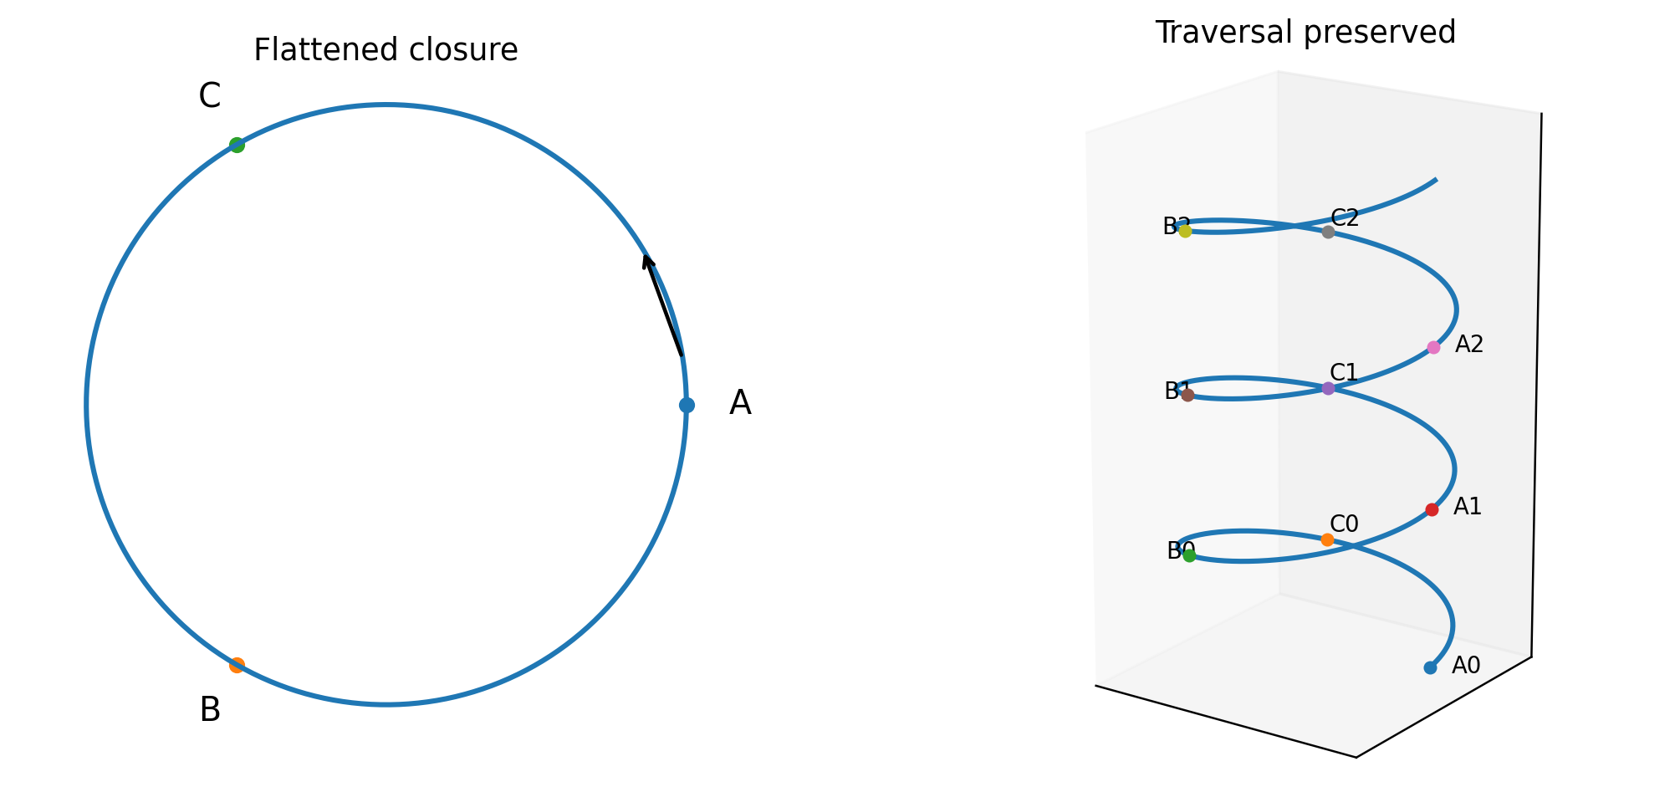
Figure 1. The same A–B–C relation shown first with traversal suppressed and then with traversal retained.

6. A Compact Mathematical Unfolding
The distinction can be expressed using a circle and its unwrapped traversal. Let the geometric loop be parameterised by an angle
θ ∈ S¹, θ ≡ θ + 2π.
On the circle, θ and θ + 2π are identified. That identification records position on the loop but suppresses how many times the loop has been traversed. Introduce an unwrapped parameter s ∈ ℝ and the projection
p(s) = eⁱˢ ∈ S¹.
Then
p(s) = p(s + 2πn), n ∈ ℤ,
even though
s ≠ s + 2πn.
This is the mathematical version of the argument. The same geometric point can be reached at distinct positions in the ordered traversal. The projection to the circle identifies them; the unwrapped parameter distinguishes them.
The A–B–C labels can be assigned by phase. For example,
Aₙ = 2πn, Bₙ = 2πn + 2π/3, Cₙ = 2πn + 4π/3.
The experienced order is therefore
Aₙ < Bₙ < Cₙ < Aₙ₊₁.
No step in this order is C → B → A. The traveller moves continually forward in the unwrapped parameter even though the projection repeats positions on the circle.

7. The Helix as the Physical Picture
A helix preserves both facts at once: cyclic repetition and forward traversal. One simple embedding is
H(s) = (R cos s, R sin s, hs), h > 0.
The first two coordinates reproduce the circle. The third coordinate records depth. After one complete turn,
H(s + 2π) = (R cos s, R sin s, hs + 2πh),
so the horizontal position repeats while the full occurrence does not. The helix does not deny cyclic structure. It denies that cyclic structure alone is sufficient to erase traversal.
In this picture, the ordinary circular CTC is a projection of a deeper ordered structure:
π(H(s)) = (R cos s, R sin s).
Flattening the helix removes the coordinate that records the completed journey. The result looks closed because the information that distinguishes one turn from the next has been discarded.

8. State Evolution and the Non-Reversal of Occurrence
Let X(s) denote the complete physical state of the traveller: body, clocks, memories, entropy and every other internal degree of freedom. Ordinary evolution along the traveller’s proper time may be written abstractly as
dX/dτ = F(X).
A genuinely identical closure requires
X(T) = X(0).
That equality is stronger than returning to the same geometric event. It requires the total physical evolution over one loop to be periodic. In operator form,
X(T) = Φ_T(X(0)), with Φ_T(X(0)) = X(0).
The initial state must therefore be a fixed point—or belong to a periodic orbit—of the complete evolution. This is precisely why CTC models require consistency conditions, memory erasure, entropy reversal or specially quantised dynamics. These mechanisms do not show that elapsed history becomes logically equivalent to no history. They enforce recurrence by constraining which histories are allowed.
The distinction is simple:
same geometric location ≠ same occurrence ≠ same accumulated state.

9. What the Argument Does and Does Not Claim
This argument does not claim that the Gödel metric is algebraically inconsistent. Nor does it claim that periodic physical systems are impossible. A pendulum, orbit or quantum state may recur.
The claim is narrower and more direct: a closed timelike curve cannot be interpreted as a reversal of the observer’s experienced order merely because the spacetime path closes. The observer still undergoes A before B, B before C and C before the returned A. To identify that returned A with the original occurrence, the theory must additionally erase, reverse or exactly recur the entire physical state that distinguishes them.
Once this extra requirement is made explicit, the usual time-travel picture changes. What has been demonstrated is not unrestricted travel backward through an already lived sequence. It is a globally constrained periodic process whose admissible states are selected to make the loop self-consistent.

10. Conclusion
The answer is not going to be located in an isolated quantum state already buried inside a model designed to defeat paradox. It begins one level earlier, where geometry and physics are required to make sense together.
A circle records recurrence of position. An observer records traversal. The moment the observer passes from A through B to C, the return to A has acquired depth. The repeated label A does not make the occurrence identical; it marks the start of a new turn. B becomes the stair between turns, and the flat loop becomes a helix.
The final conclusion is therefore concise:
A closed path may repeat its geometry, but it cannot reverse the order of its own traversal. To make the end identical to the beginning, a theory must remove or reverse the physical history that made the journey occur. That may produce a consistent loop. It does not, by itself, produce meaningful travel into one’s own already-lived past.

References
1. Gödel, K. (1949). “An Example of a New Type of Cosmological Solutions of Einstein’s Field Equations of Gravitation.” Reviews of Modern Physics, 21, 447–450.
2. Deutsch, D. (1991). “Quantum Mechanics Near Closed Timelike Lines.” Physical Review D, 44, 3197–3217.
3. Gavassino, L. (2024). “Life on a Closed Timelike Curve.” Classical and Quantum Gravity; arXiv:2405.18640.
4. Luminet, J.-P. (2021). “Closed Timelike Curves, Singularities and Causality: A Survey from Gödel to Chronological Protection.” arXiv:2101.08592.

